# RASPBERRY PI 5

The Raspberry Pi 5 is a small, affordable, and powerful single-board computer developed by the Raspberry Pi Foundation. It is the latest and most advanced version of the Raspberry Pi family.

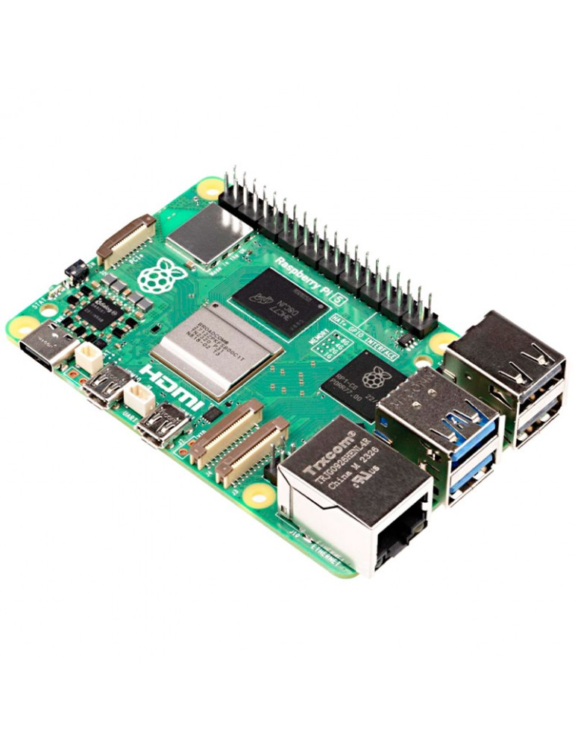

## Features

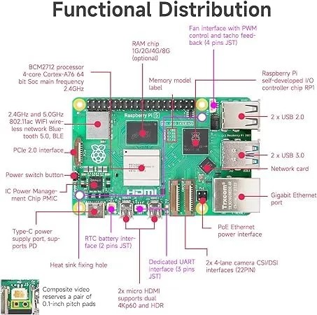

1. Processor - Quad-core ARM Cortex-A76 @ 2.4GHz which is up to 3x faster than Raspberry Pi 4
2. RAM Options – 2GB, 4GB, 8GB or 16GB LPDDR4X RAM
3. Storage - MicroSD card slot and aPCIe 2.0 x1 (via FPC connector) which supports NVMe SSDs
4. Graphics & Display - VideoCore VII GPU and two micro-HDMI ports (up to 4K@60Hz each)
5. USB Ports - 2 USB 3.0 and 2 USB 2.0
6. Networking - Gigabit (1Gb/s) Ethernet RJ45 with PoE+ support

2.4/5GHz dual-band 802.11ac Wi-Fi 5 (300Mb/s)

Bluetooth 5, Bluetooth Low Energy (BLE)

1. Camera & Display Interfaces- 2 CSI (camera) connectors and 2 DSI (display) connectors
2. Power Supply - USB-C, 5V/5A (25W recommended). It has a power button included
3. GPIO & Expansion - Standard 40-pin GPIO header

PCIe expansion support

Real-Time Clock (RTC) support (external battery needed)

1. Cooling - Improved thermal management. Supports active cooling (official fan & case available) and a heat sink slot

## Communication

Raspberry Pi 5 interacts with external systems using various interfaces and protocols:

1. Wired Communication:

* GPIO Pins (40-pin header): For custom digital/analog I/O with sensors, switches, LEDs, and more.
* I2C, SPI, UART: Serial communication protocols via GPIO for peripherals like IMUs, EEPROMs, GPS, etc.
* USB 3.0 / 2.0 Ports: Connect peripherals like storage devices, keyboards, cameras, or microcontrollers.
* HDMI Ports: Send video/audio to external displays.
* Gigabit Ethernet: For high-speed, stable network communication.
* PCIe Interface: Attach high-speed peripherals like SSDs, radios, or custom boards via an adapter.

1. Wireless Communication:

* Wi-Fi 5 (802.11ac): Dual-band for internet or LAN-based data transfer.
* Bluetooth 5.0 / BLE: Connect to low-power devices like sensors, controllers, or smartphones.

1. Other Interfaces:

* microSD Slot: Load OS and read/write data.
* Camera & Display Ports (MIPI): Use CSI/DSI interfaces for image capture or GUI display.

## Pin out

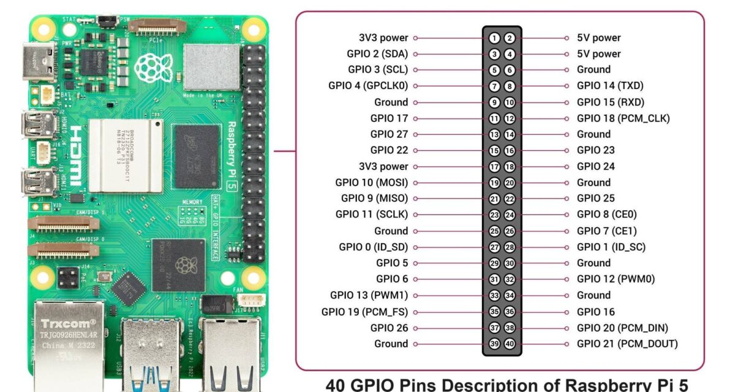

The Raspberry Pi 5 has a 40-pin GPIO header, which is the same GPIO header from Raspberry Pi 4. You can use the GPIO header to connect a variety of sensors, actuators, and other electronic devices to the Raspberry Pi. The table below shows the GPIO pinout for the Raspberry Pi 5.

| **Pin** | **Name** | **Function** |
| --- | --- | --- |
| 1 | 3.3V | 3.3V power supply |
| 2 | 5V | 5V power supply |
| 3 | GPIO 2 | I2C1 SDA (Data Line) |
| 4 | 5V | 5V power supply |
| 5 | GPIO 3 | I2C1 SCL (Clock Line) |
| 6 | Ground | Ground |
| 7 | GPIO 4 | General-purpose input/output |
| 8 | GPIO 14 | UART TXD (Transmit Data) |
| 9 | Ground | Ground |
| 10 | GPIO 15 | UART RXD (Receive Data) |
| 11 | GPIO 17 | General-purpose input/output |
| 12 | GPIO 18 | PCM_CLK (Pulse Code Modulation Clock) |
| 13 | GPIO 27 | General-purpose input/output |
| 14 | Ground | Ground |
| 15 | GPIO 22 | General-purpose input/output |
| 16 | GPIO 23 | General-purpose input/output |
| 17 | 3.3V | 3.3V power supply |
| 18 | GPIO 24 | General-purpose input/output |
| 19 | GPIO 10 | SPI0 MOSI (Master Out, Slave In) |
| 20 | Ground | Ground |
| 21 | GPIO 9 | SPI0 MISO (Master In, Slave Out) |
| 22 | GPIO 25 | General-purpose input/output |
| 23 | GPIO 11 | SPI0 SCLK (Clock Line) |
| 24 | GPIO 8 | SPI0 CE0 (Chip Enable 0) |
| 25 | Ground | Ground |
| 26 | GPIO 7 | SPI0 CE1 (Chip Enable 1) |
| 27 | GPIO 0 | I2C EEPROM Data Line / ID_SD |
| 28 | GPIO 1 | I2C EEPROM Clock Line / ID_SC |
| 29 | GPIO 5 | General-purpose input/output |
| 30 | Ground | Ground |
| 31 | GPIO 6 | General-purpose input/output |
| 32 | GPIO 12 | PWM (Pulse Width Modulation) |
| 33 | GPIO 13 | PWM (Pulse Width Modulation) |
| 34 | Ground | Ground |
| 35 | GPIO 19 | PCM_FS (Frame Sync for Pulse Code Modulation) |
| 36 | GPIO 16 | General-purpose input/output |
| 37 | GPIO 26 | General-purpose input/output |
| 38 | GPIO 20 | PCM_DIN (Data In for Pulse Code Modulation) |
| 39 | Ground | Ground |
| 40 | GPIO 21 | PCM_DOUT (Data Out for Pulse Code Modulation) |

## Power

1. Powering the Raspberry Pi 5 with USB-C power supply. Raspberry Pi sells its official 5.1V 5A 27W USB-C PSU which is made specifically for the Raspberry Pi 5 (well, and the Pi 500, CM5, etc) which has a “requirement” of 5A so as to not limit the USB ports current to 600mA by default.
2. Using GPIO Header. This is an advanced method and is not Recommended for Beginners. It involves supplying 5V and GND directly to the GPIO pins as Pin 2 or 4: +5V and Pin 6 or 9: GND. This method has no protection circuitry hence risky if the voltage isn't regulated precisely to 5V.
3. Power over Ethernet (PoE+) - Requires the Raspberry Pi PoE+ HAT (sold separately). PoE+ HAT is a Power over Ethernet add-on board for Raspberry Pi that utilizes the PoE+ standard to deliver both power and data over a single Ethernet cable. It allows for power delivery from a PoE+ switch or injector to the Raspberry Pi, instead of relying on a separate power supply.

## Programming

Getting started with Raspberry Pi 5 you'll require:

1. Raspberry Pi Board (e.g., Pi 5)
2. microSD Card (minimum 8GB, Class 10 recommended)
3. Power Supply (USB-C, 5V/3A or higher)
4. Display (HDMI-compatible monitor or TV)
5. HDMI Cable (micro-HDMI to standard HDMI)
6. USB Keyboard and Mouse
7. Internet Connection (via Ethernet or Wi-Fi)

Installing the Operating System

1. Download Raspberry Pi Imager: Available for Windows, macOS, and Linux from the official website.
2. Insert microSD Card: Connect it to your computer using a card reader.
3. Launch Raspberry Pi Imager:
   * Choose OS: Select "Raspberry Pi OS (32-bit)" or another preferred OS.
   * Choose Storage: Select your connected microSD card.
   * Write: Click "Write" to install the OS onto the card.
4. Insert microSD Card into Pi: Once imaging is complete, safely eject the card and insert it into your Raspberry Pi.

First Boot and Configuration

1. Connect Peripherals: Attach your keyboard, mouse, and monitor to the Raspberry Pi.
2. Power Up: Connect the power supply to boot the Pi.
3. Initial Setup:
   * Set Locale: Choose your country, language, and time zone.
   * Change Password: Replace the default password for security.
   * Connect to Wi-Fi: If not using Ethernet, select your network and enter the password.
   * Update Software: Allow the system to check for and install updates.

You can use Raspberry Pi 5 in two modes ie Desktop and Headless Setup

* Desktop Mode: Utilize the Raspberry Pi with a connected monitor, keyboard, and mouse for a traditional desktop experience.
* Headless Mode: Operate the Pi without a monitor or keyboard by enabling SSH or VNC, allowing remote access over the network.

Enabling Interfaces

To expand the Pi's capabilities:

1. Open Raspberry Pi Configuration: Found under Preferences in the main menu.
2. Navigate to Interfaces Tab:
   * Enable SSH: Allows remote terminal access.
   * Enable VNC: Provides remote desktop access.
   * Enable SPI, I2C, Serial: For hardware interfacing with various sensors and modules.

With your Raspberry Pi set up, you can now explore programming

The Pi 5 supports almost any language. The most popular options are;

* 1. Python (Best for Beginners) - Pre-installed on Raspberry Pi OS. Great for GPIO, robotics, sensors, and AI.
  2. C/C++ (High Performance). Ideal for hardware control (e.g., custom drivers). Use WiringPi (deprecated but alternatives like libgpiod exist).
  3. JavaScript (Node.js) - For web apps/IoT (using Node.js + onoff for GPIO).
  4. Bash scripting (for automation).
  5. Java/Kotlin (Android Things compatibility).
  6. Rust (for embedded safety).

## Other features

Raspberry Pi 5 does not have a built-in 3.5mm audio jack like older models.

To get Audio output use;

1. HDMI Audio (Default) - If your monitor or TV has speakers, just connect via HDMI. Audio will come out through the screen.
2. Use a USB sound card or plug in USB speakers. The Pi will detect it automatically.
3. Bluetooth headphones or speakers - Pair the device in Bluetooth settings. Set it as the default audio output.

## Price

|  |  |
| --- | --- |
| **Vendor** | **Price (Ksh.)** |
| Nerokas | 19500 |
| Jumia | 20300 |
| Pixel Electric | 19500 |

## Advantages

* 1. Faster Performance
* Powered by a 2.4GHz quad-core Cortex-A76 CPU, which is 2–3× faster than Pi 4.
* Great for multitasking, running software smoothly, and handling heavier workloads.
  1. Better Graphics
* VideoCore VII GPU supports dual 4K displays at 60Hz, Vulkan 1.2, and OpenGL ES 3.1.
* Ideal for video streaming, digital signage, and light gaming.
  1. Improved Connectivity
* 2× USB 3.0 ports for faster data transfer.
* Gigabit Ethernet and Bluetooth 5.0 for better network and device connections.
* Dual-band Wi-Fi for strong internet access.
  1. Expandability
* PCIe 2.0 interface lets you add fast SSDs, AI accelerators, and more (via adapter).
* 2× MIPI camera/display connectors for advanced camera setups or extra displays.
  1. Enhanced Power Management
* USB-C power input (5V/5A) supports Power Delivery for stable performance.
* Has a real-time clock (RTC) with external battery support and a power button—both new features.
  1. Better Memory
* Uses LPDDR4X-4267 RAM (faster and more efficient).
* Multiple RAM options (4GB or 8GB).
  1. Software Compatibility
* Works with Raspberry Pi OS and other Linux distros.
* Supports programming in Python, C, C++, Java, etc.

## Disadvantages

1. No Audio Jack

* Unlike older models (like Pi 4), Pi 5 doesn't have a 3.5mm audio jack.
* You need to use HDMI, USB sound cards, or Bluetooth for audio.

1. Higher Power Requirements

* Needs a 5V/5A USB-C power supply.
* Many older or basic power adapters/power banks may not work well.

1. No Built-in eMMC Storage

* Still relies on a microSD card for storage (slower than internal storage).
* You need to buy and manage external storage for better speed

1. More Heat

* Faster processor generates more heat.
* A cooling fan or heatsink is recommended, especially during heavy tasks.

1. Not Beginner-Friendly for Some Tasks

* Features like PCIe, RTC, and MIPI connectors are powerful but require technical skills to use.

## Comparision with other raspberry Pi models

|  |  |  |  |  |  |
| --- | --- | --- | --- | --- | --- |
| **Feature** | **RPi 1 B+** | **RPi 2 B** | **RPi 3 B+** | **RPi 4 B** | **RPi 5** |
| **Release Year** | 2014 | 2015 | 2018 | 2019 | 2023 |
| **CPU** | 700MHz Cortex-A7 (Single) | 900MHz Quad-core Cortex-A7 | 1.4GHz Quad-core Cortex-A53 | 1.5GHz Quad-core Cortex-A72 | 2.4GHz Quad-core Cortex-A76 |
| **GPU** | VideoCore IV | VideoCore IV | VideoCore IV | VideoCore VI | VideoCore VII (Vulkan 1.2) |
| **RAM** | 512MB LPDDR2 | 1GB LPDDR2 | 1GB LPDDR2 | 2GB / 4GB / 8GB LPDDR4 | 4GB or 8GB LPDDR4X-4267 |
| **Storage** | microSD | microSD | microSD | microSD, USB boot | microSD, PCIe SSD (via adapter) |
| **USB Ports** | 4 × USB 2.0 | 4 × USB 2.0 | 4 × USB 2.0 | 2 × USB 3.0, 2 × USB 2.0 | 2 × USB 3.0, 2 × USB 2.0 |
| **Ethernet** | 10/100 Mbps | 10/100 Mbps | 10/100 Mbps | Gigabit (shared with USB) | True Gigabit + PoE+ support |
| **Wi-Fi** | ❌ | ❌ | 802.11n (Wi-Fi 4) | 802.11ac (Wi-Fi 5) | 802.11ac (Wi-Fi 5, dual-band) |
| **Bluetooth** | ❌ | ❌ | Bluetooth 4.2 | Bluetooth 5.0 | Bluetooth 5.0 / BLE |
| **HDMI Output** | 1 × HDMI | 1 × HDMI | 1 × HDMI | 2 × micro-HDMI (4Kp30) | 2 × micro-HDMI (4Kp60 with HDR) |
| **Audio Output** | 3.5mm + HDMI | 3.5mm + HDMI | 3.5mm + HDMI | 3.5mm + HDMI | HDMI / USB / Bluetooth only |
| **Camera Interface** | 1 × MIPI CSI | 1 × MIPI CSI | 1 × MIPI CSI | 1 × MIPI CSI | 2 × 4-lane MIPI transceivers |
| **Display Interface** | 1 × DSI | 1 × DSI | 1 × DSI | 1 × DSI | 2 × 4-lane MIPI transceivers |
| **PCIe Support** | ❌ | ❌ | ❌ | ❌ | ✅ PCIe 2.0 x1 (via FFC adapter) |
| **RTC (Real-Time Clock)** | ❌ | ❌ | ❌ | ❌ | ✅ (with external battery) |
| **Power Supply Type** | 5V/2A micro-USB | 5V/2A micro-USB | 5V/2.5A micro-USB | 5V/3A USB-C | 5V/5A USB-C with Power Delivery |
| **Cooling Required** | Low | Low | Low | Medium | High – active cooling needed |
| **GPIO Header** | 26 pins | 40 pins | 40 pins | 40 pins | 40 pins |

## Relevance to satellite project

Raspberry Pi 5 is much relevant to the satellite project because of;

|  |  |
| --- | --- |
| 1. High Processing Power | Cortex-A76 CPU enables advanced data processing, image handling, or AI models on-board. |
| 1. GPIO + Serial Protocols (I2C/SPI/UART) | Easily connect satellite subsystems like attitude sensors, GPS modules, or power systems. |
| 1. Low Size, Weight, and Power (SWaP) | Compact design and efficient power use make it suitable for CubeSat/nanosat structures. |
| 1. Camera Interface (MIPI CSI) | Capture Earth images or payload visuals directly. |
| 1. Linux OS Support | Full OS allows multitasking, logging, real-time health monitoring, and remote updates. |
| 1. Wireless (for Ground Testing) | Use Wi-Fi/Bluetooth for simulation, telemetry, or debugging during ground-based prototyping. |
| 1. Storage + PCIe Option | High-speed SSD or flash memory for storing payload data or logs. |
| 1. Community and Tools | Rich documentation and global community simplify prototyping and testing. |

Raspberry pi 5 best fits in On Board computer subsystem because of powerful data processing, data storage, task scheduling, subsystems coordination, health monitoring and software flexibility.

Raspberry Pi 5 can also best fit in payload subsystem for satellites whose primary mission involves imaging, sensors and/or computation.